LC#21 MERGE TWO SORTED LINKED LIST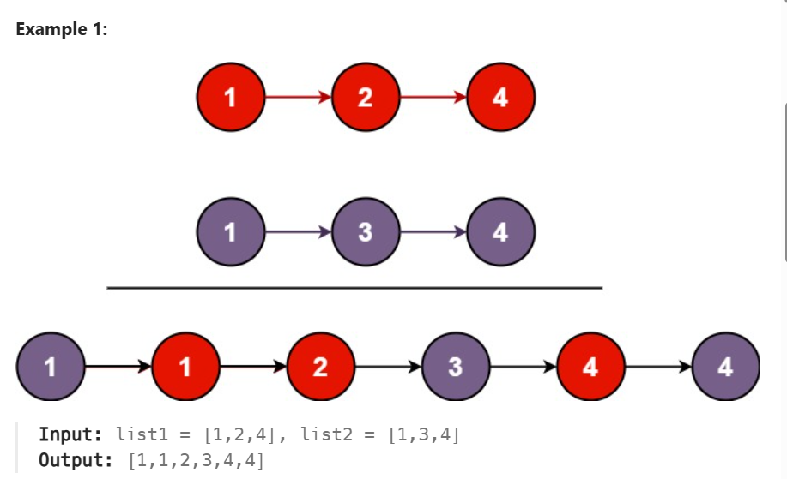
APPROACH:
->create a dummy and tail node
->initial dummy is like -1 or null(assume) compare both the curr elements of the list
-> point tail to the smaller one(tail.next) bcoz initial is null

CODE:
class Solution {
public ListNode mergeTwoLists(ListNode list1, ListNode list2) {
ListNode dummy = new ListNode(-1);
ListNode tail = dummy;
while(list1!=null && list2!=null)
{
if(list2.val <list1.val)
{
tail.next = list2;
list2 =list2.next;
}
else
{
tail.next = list1;
list1 = list1.next;
}
tail = tail.next;
}
tail.next = (list1==null)?list2:list1;
return dummy.next;

}
}

